**Managing File Permissions**

## Accessing the AWS Management Console

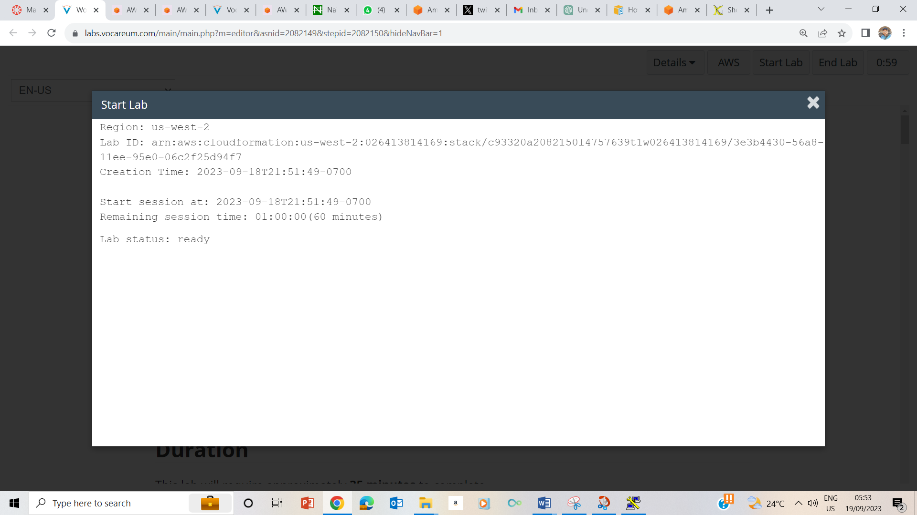

1. Clicked on the Start handle until the pop up showed that Lab Status Ready

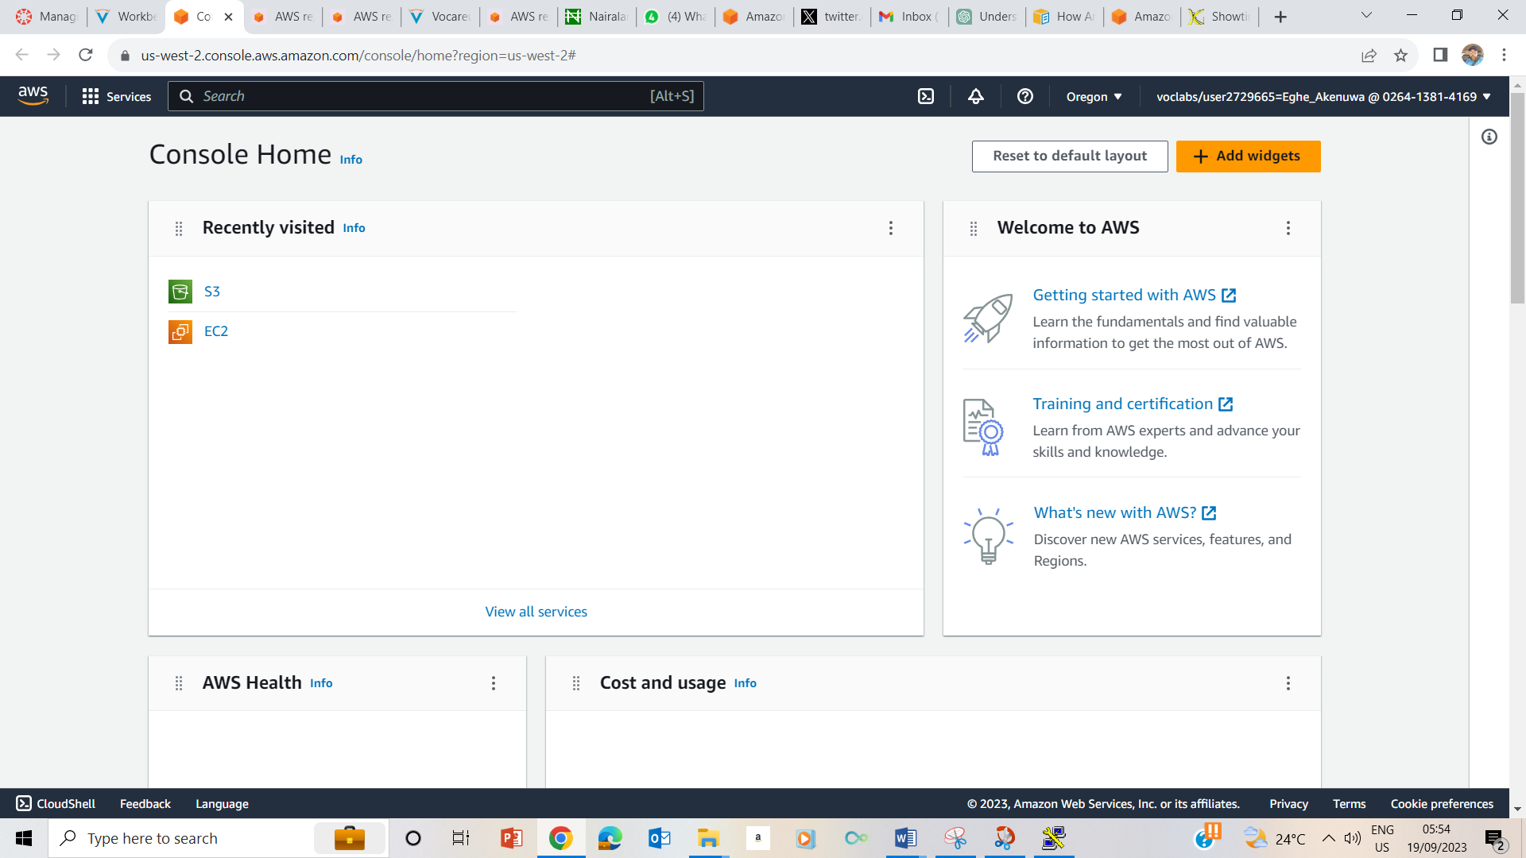

1. 3 Clicked on the AWS handle to show the above page already signed in.

## Task 1: Use SSH to connect to an Amazon Linux EC2 instance

### Windows Users: Using SSH to Connect

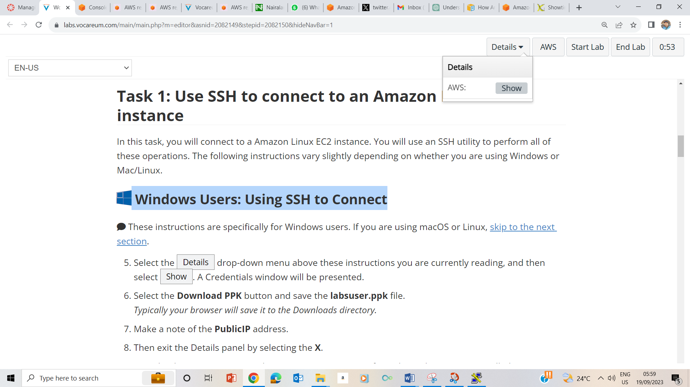

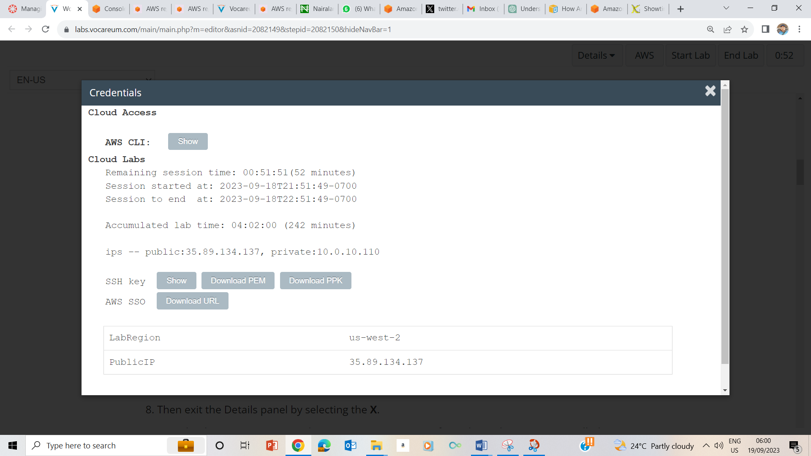

5-8. Selected the Details Drop down, selected Show; and on the credentials page, downloaded PPK. Noted the PublicIP as 35.89.134.137, then exited the Details panel by selecting the X.

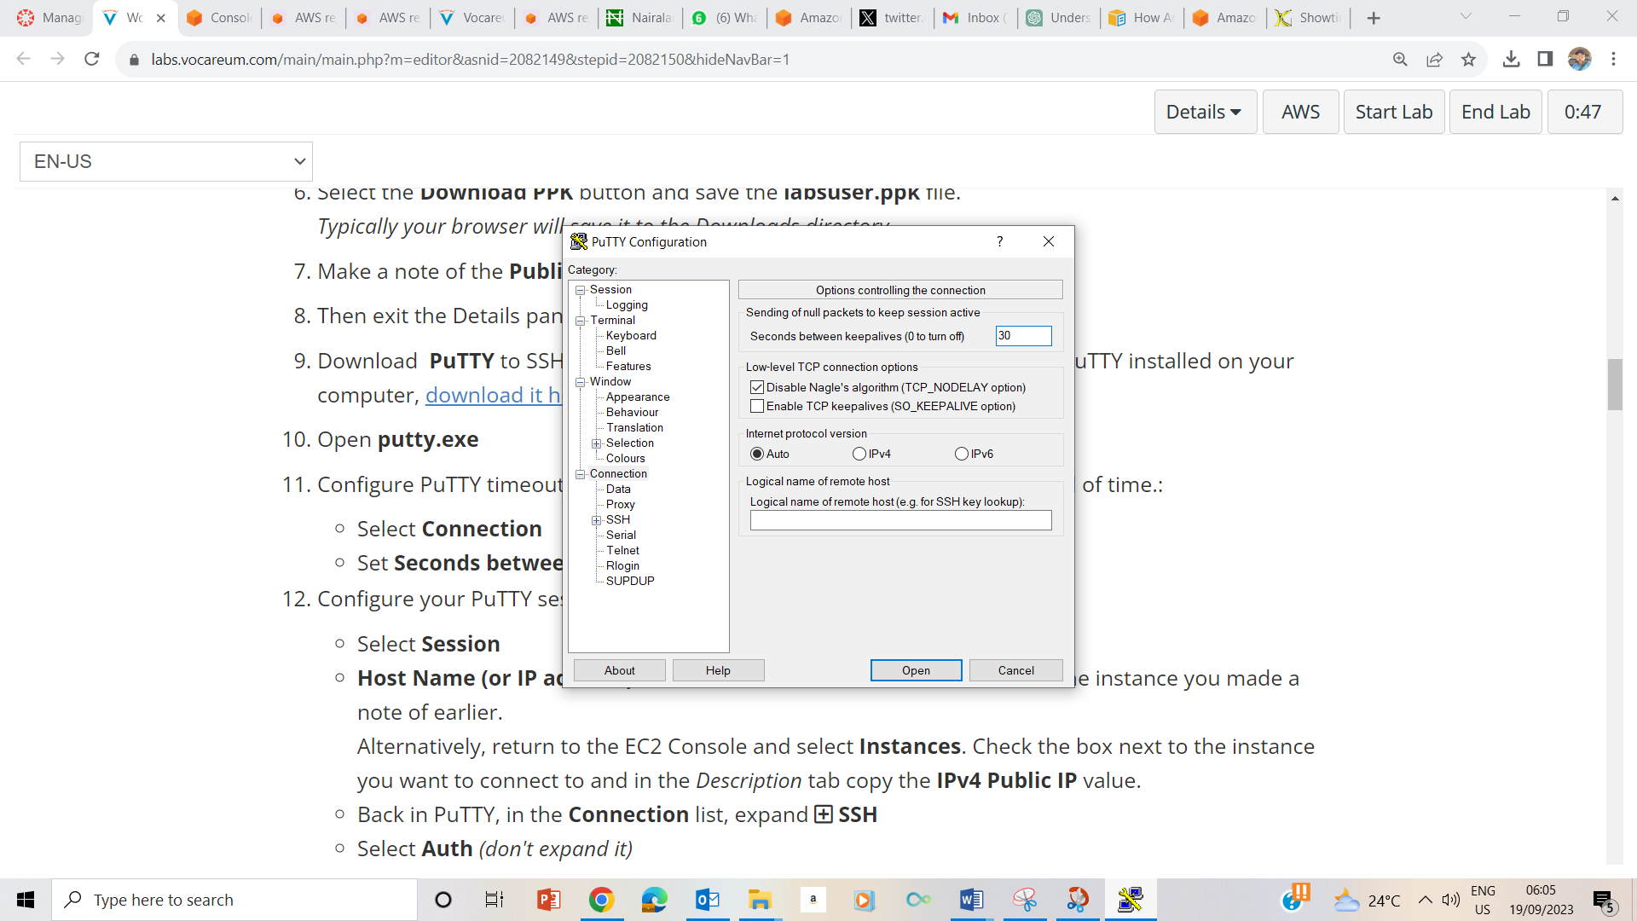

9-11 Downloaded Putty, opened putty.exe, selected connection, set seconds between time out to be 30.

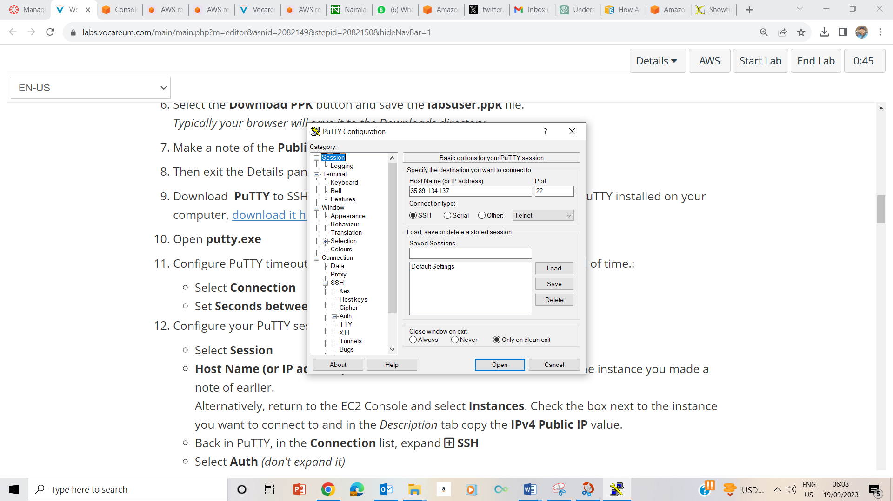

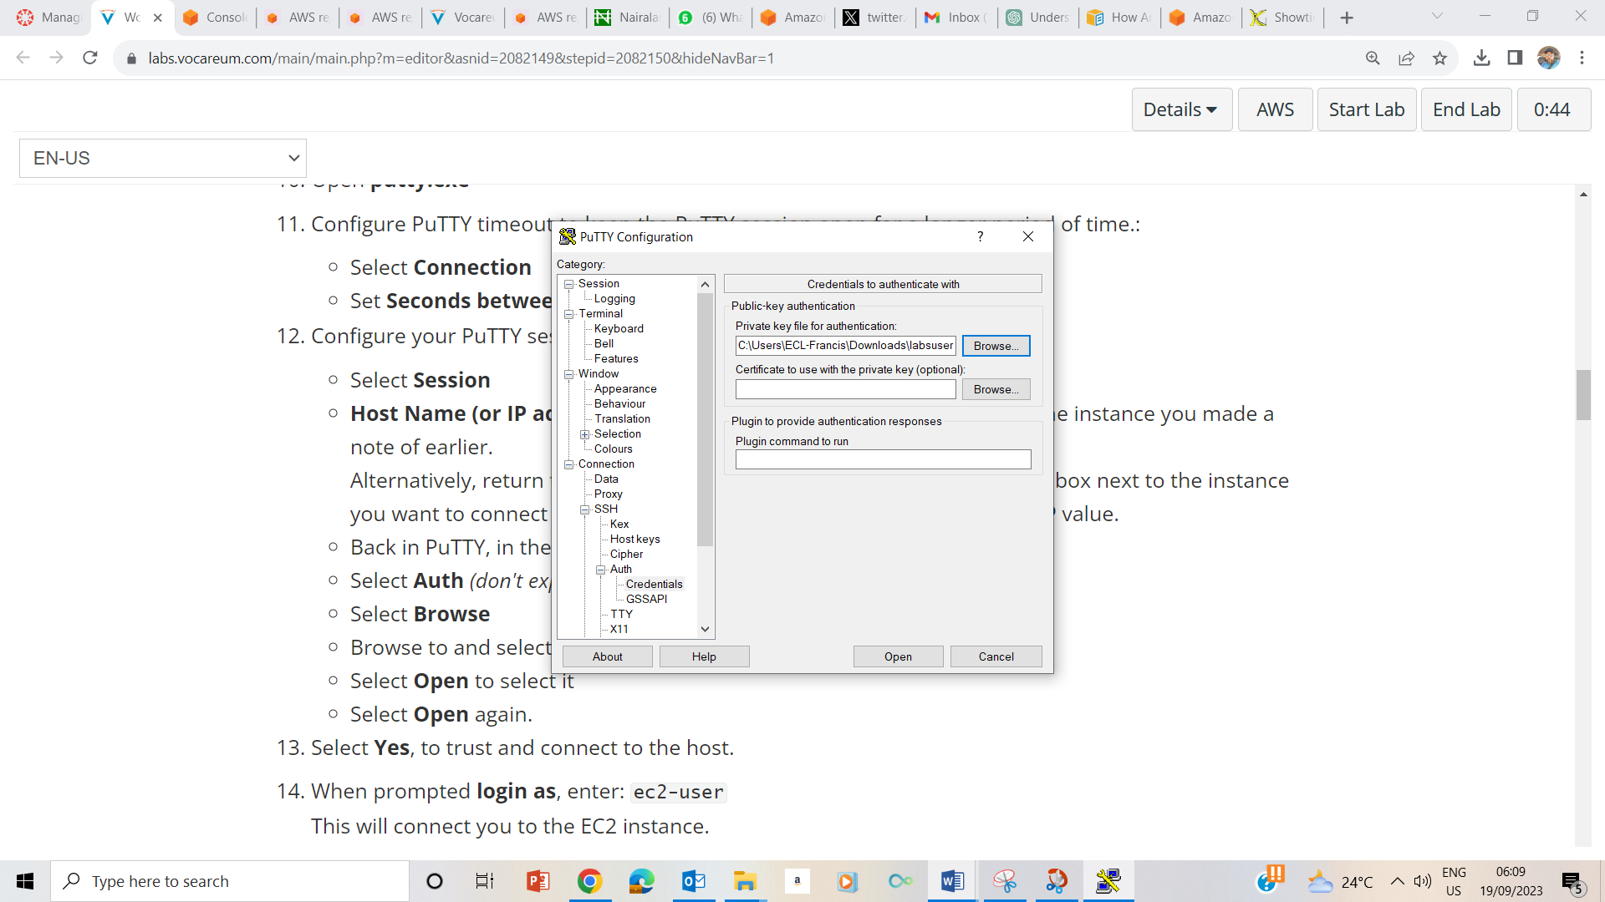

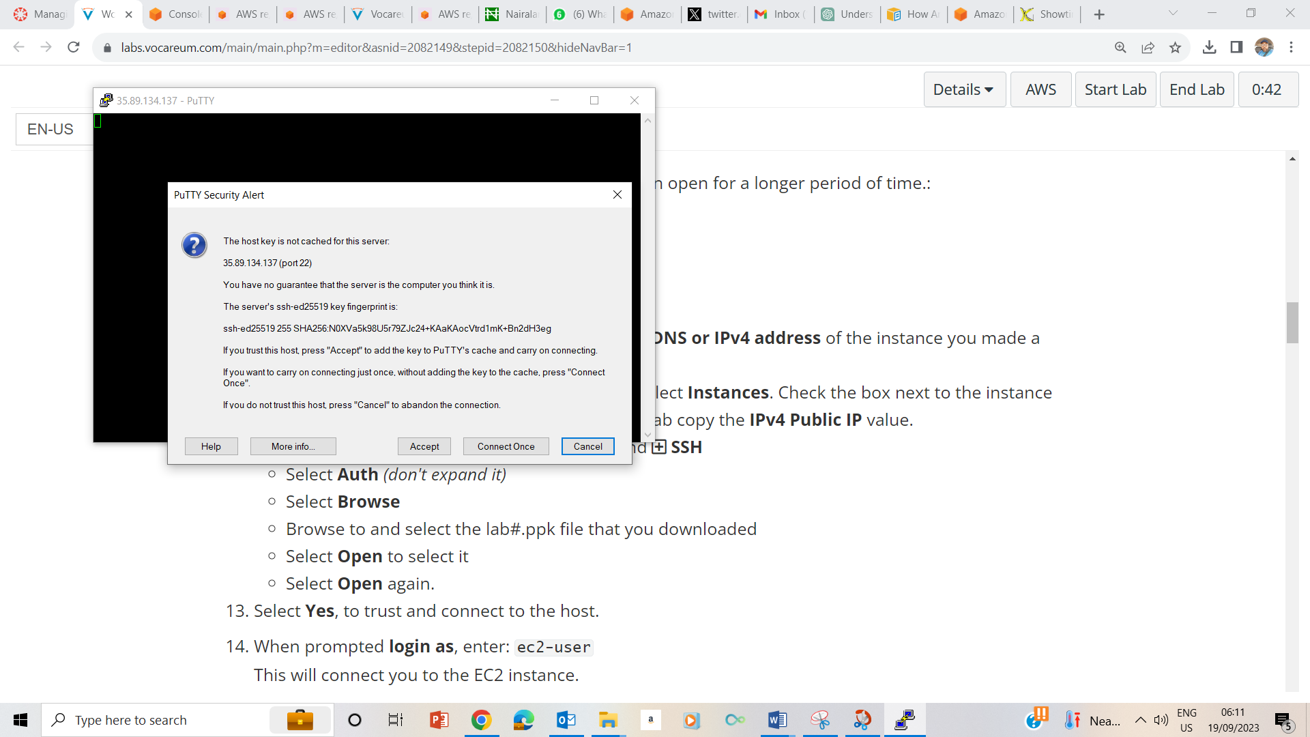

10-14

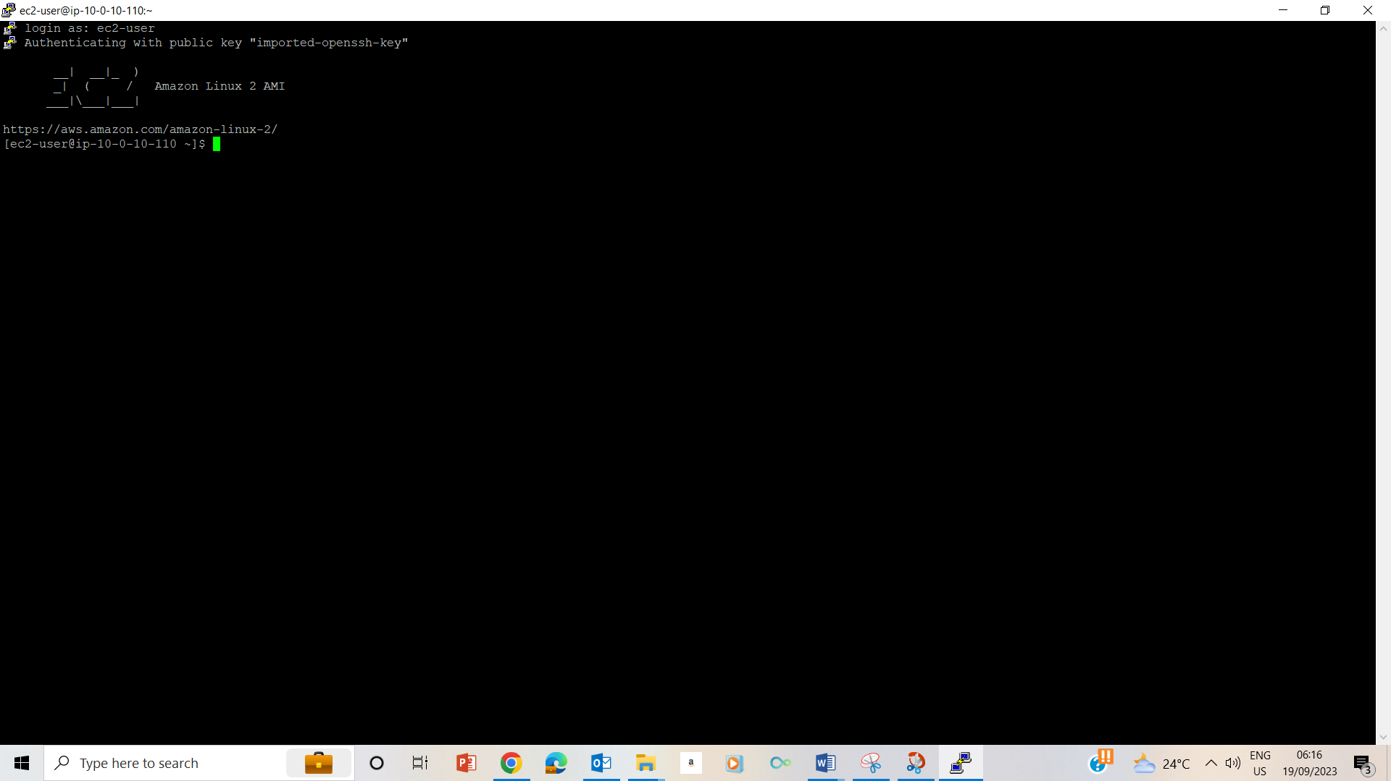

15. Logged in as ec2-user

## Task 2: Change file and folder ownership

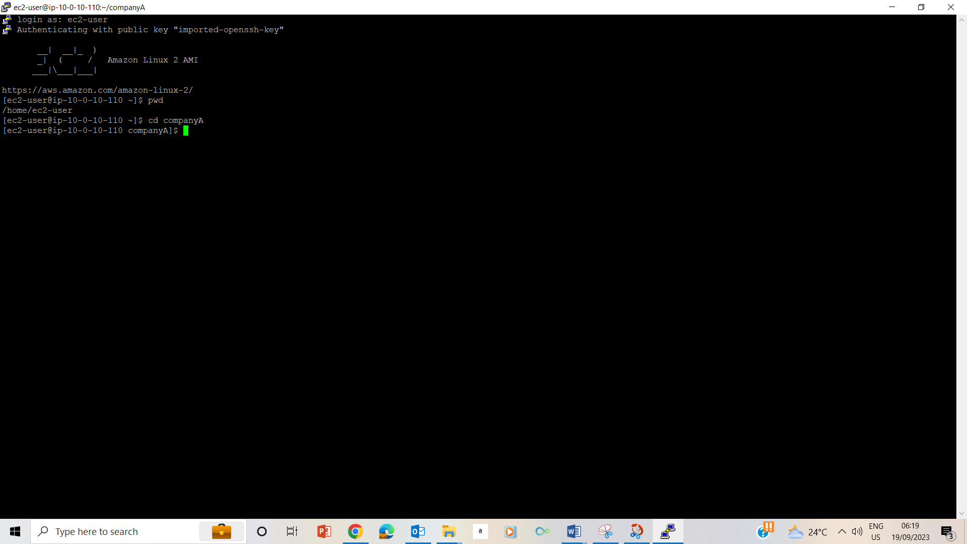

24-27. used pwd to check my present working directory, and did cd companyA to go to companyA folder.

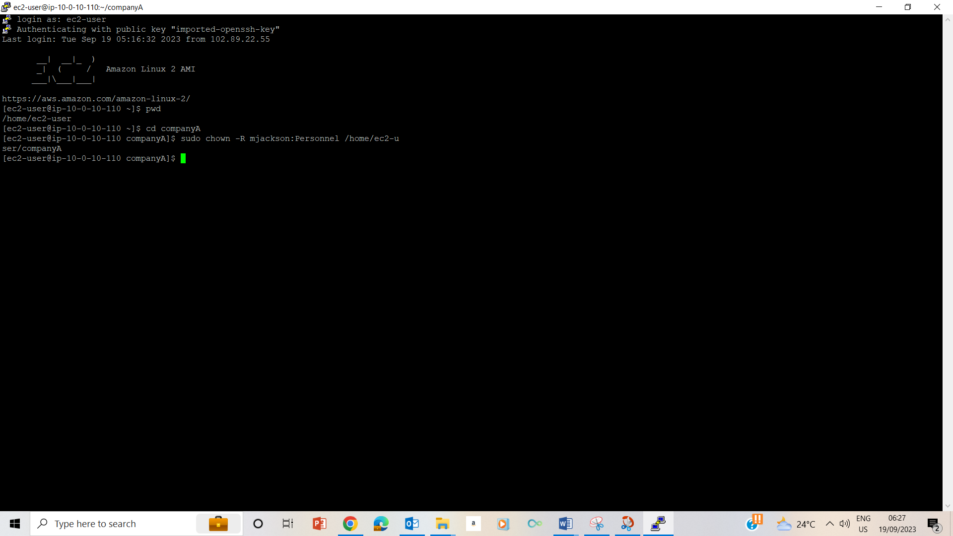

28. Changed ownership of the companyA folder to the CEO mjackson and the group ownershio to Personnel by typing sudo chown –R mjackson:Personnel /home/ec2-user/companyA

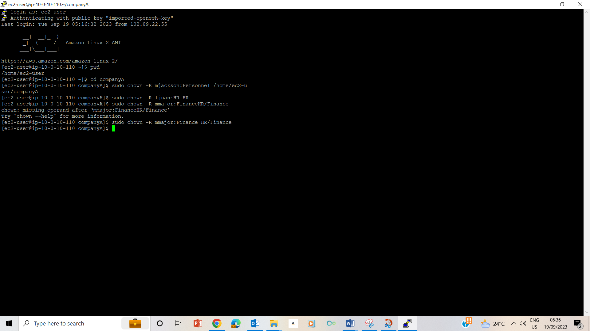

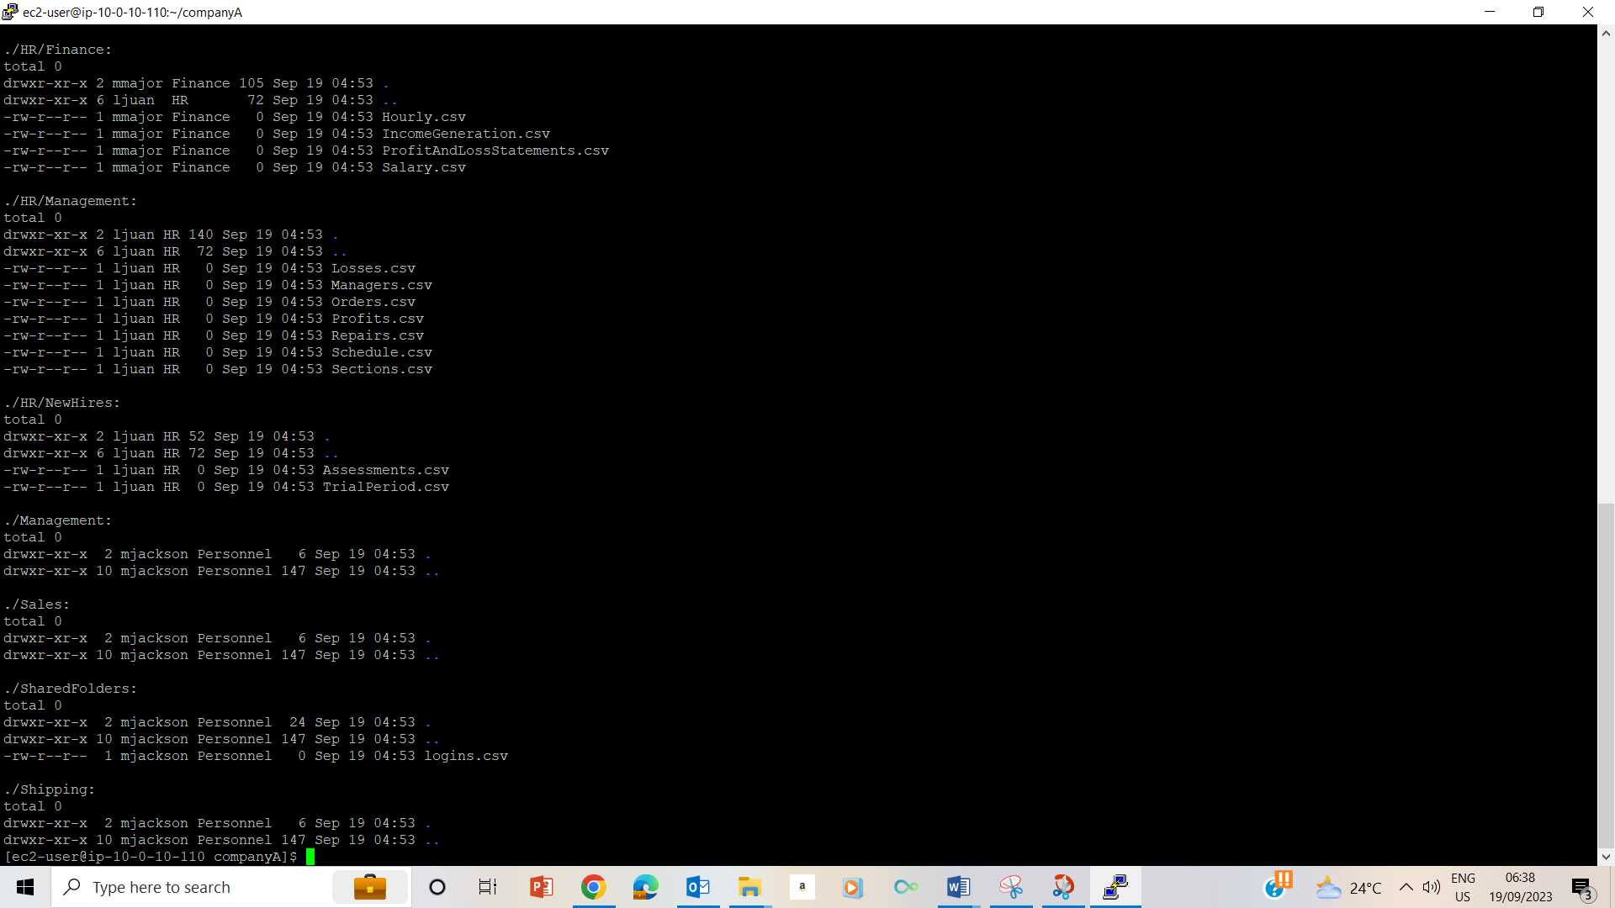

28-31 Changed the ownership of the files and validated the changes using ls –laR command

## Task 3: Change permission modes

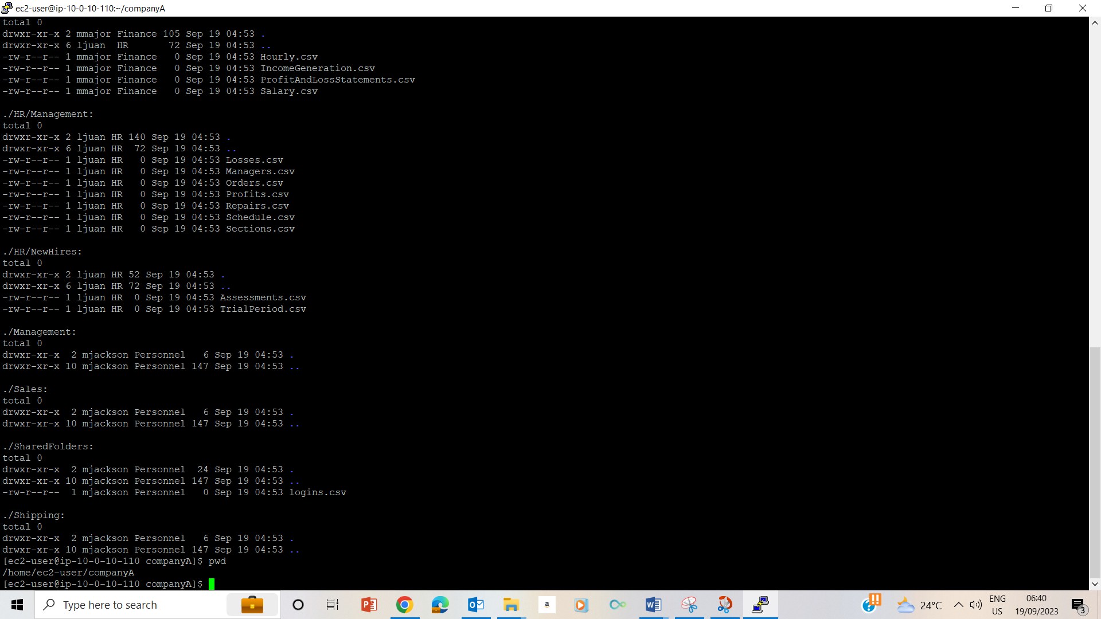

32. typed pwd and pressed enter to validate that I was on the home directory.

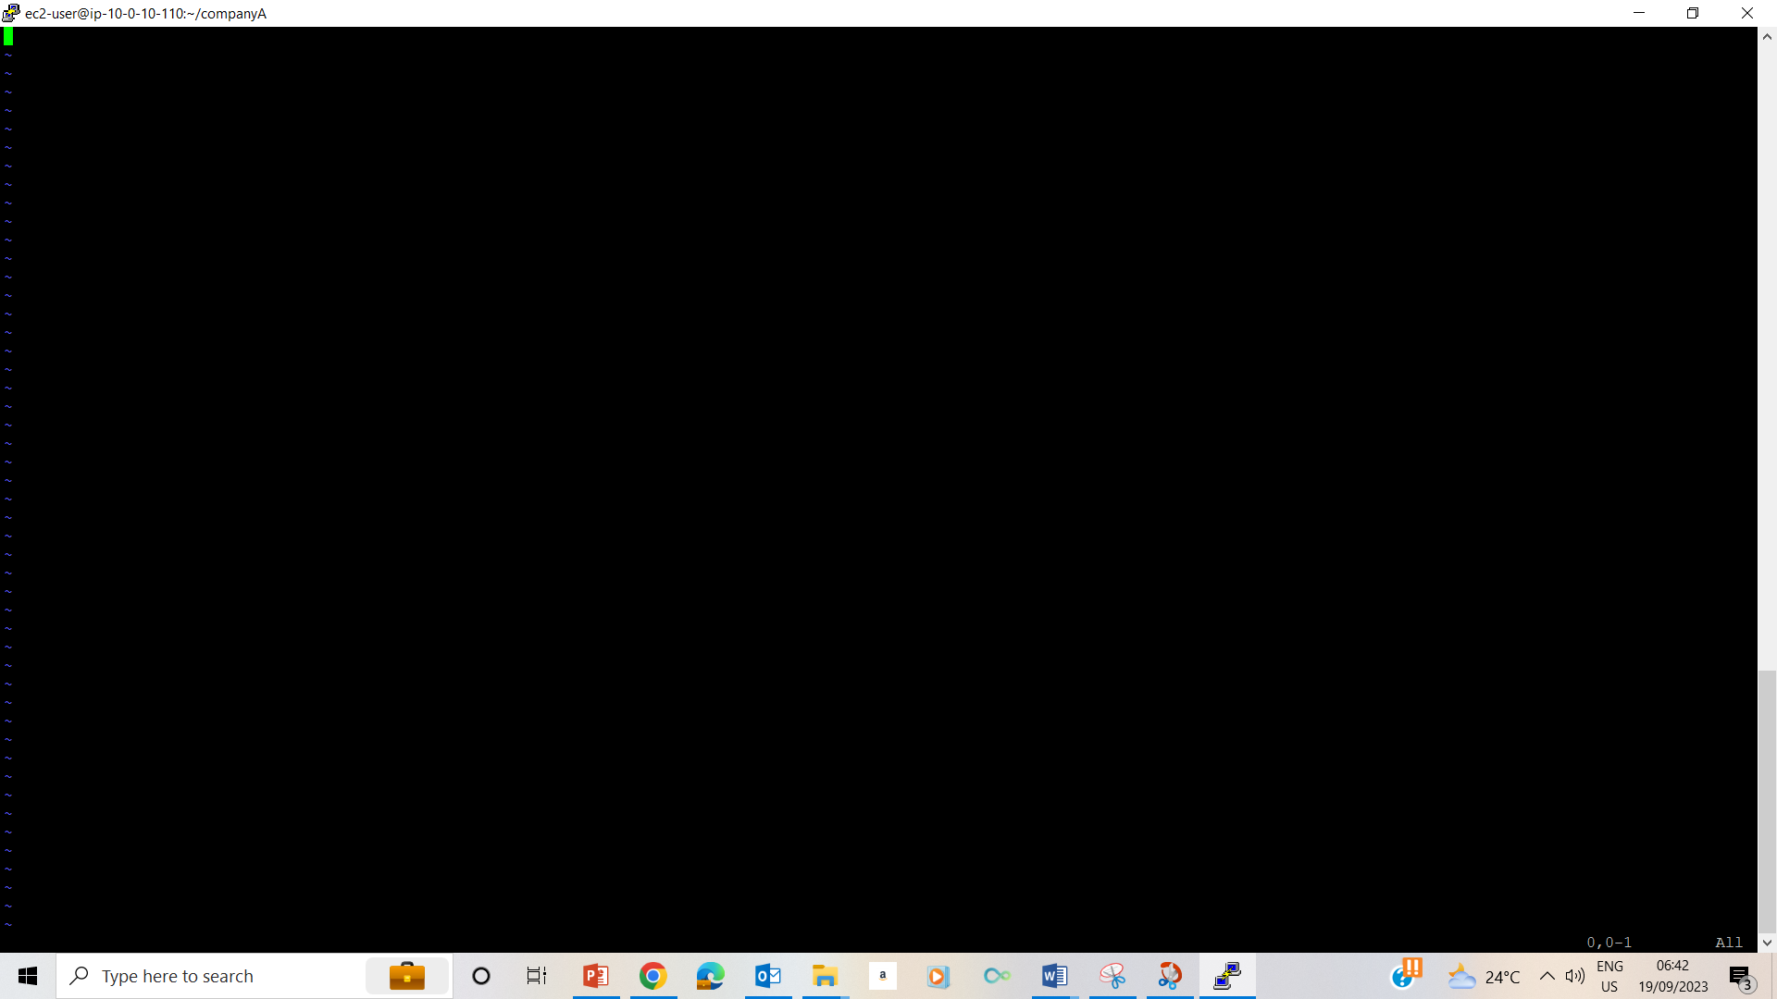

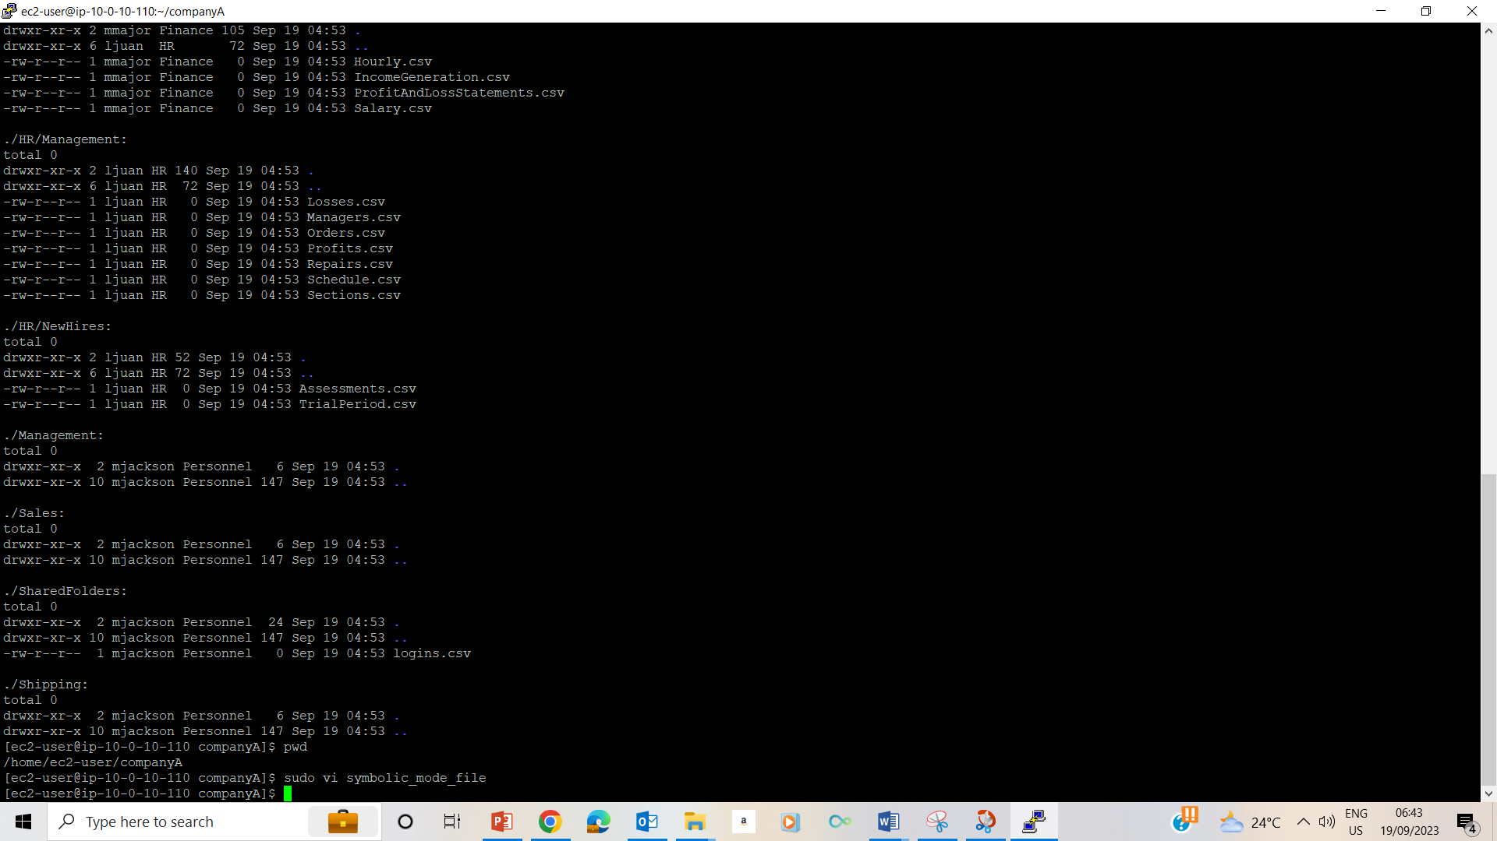33-34

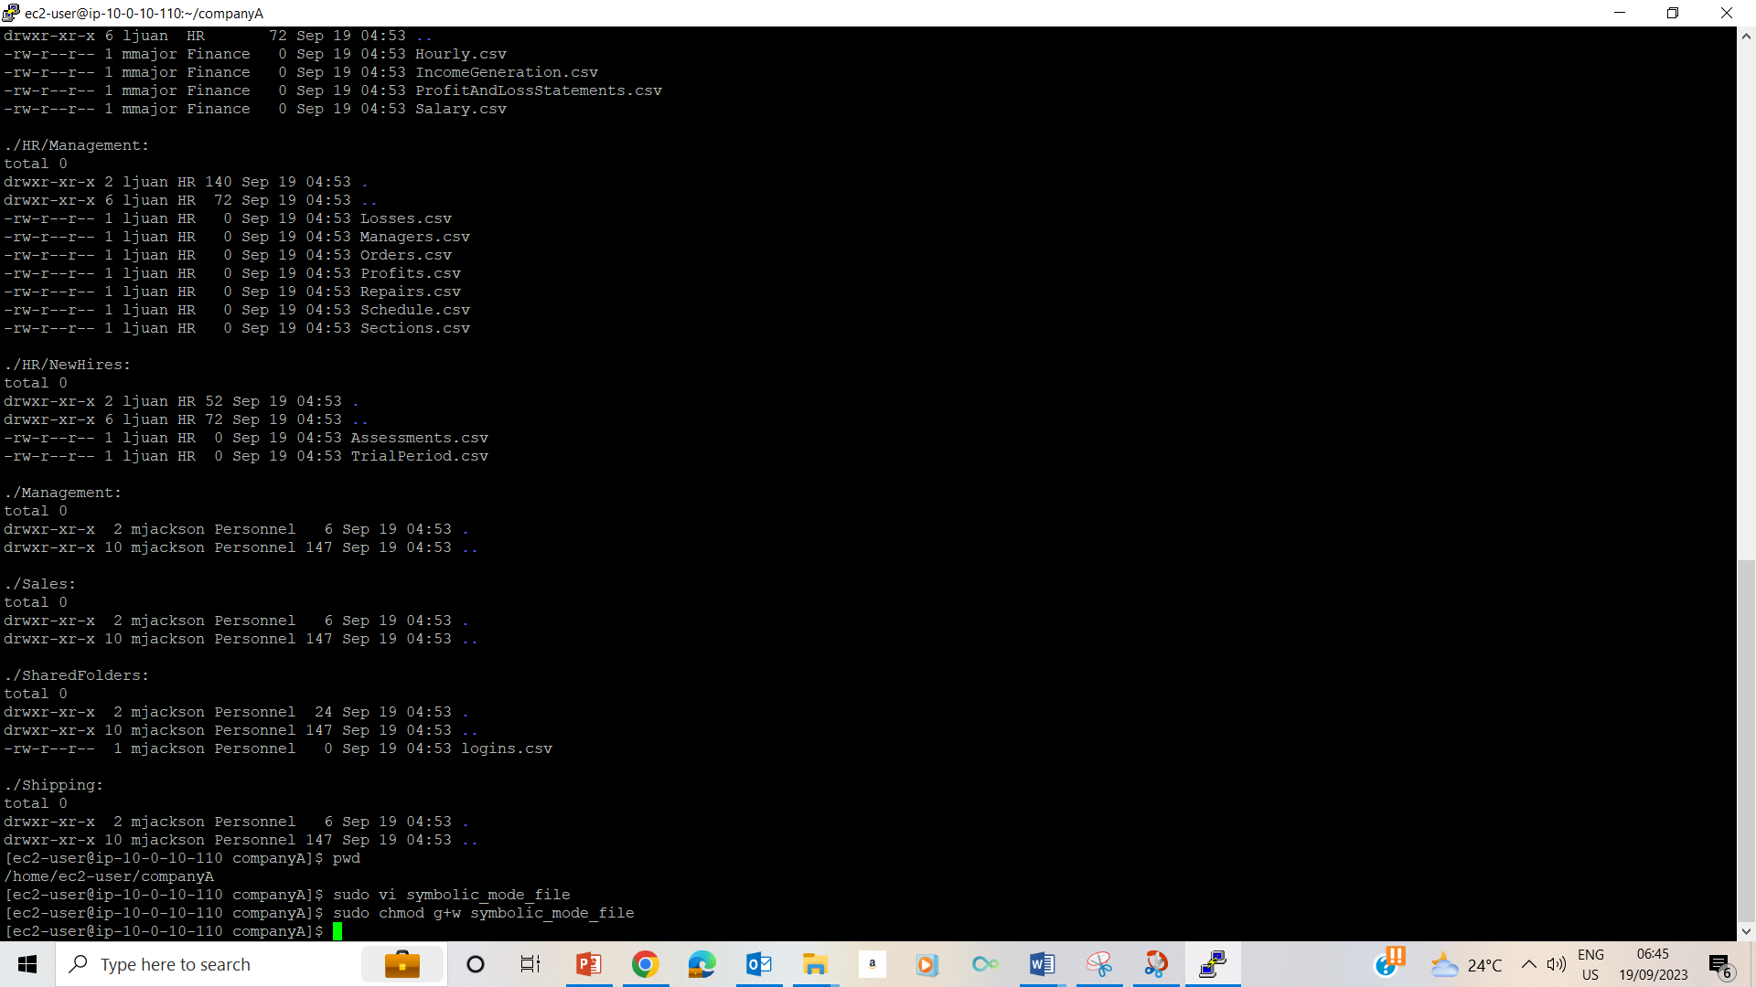

35- using chmod to give write rights to the symbolic_mode_file

Sudo

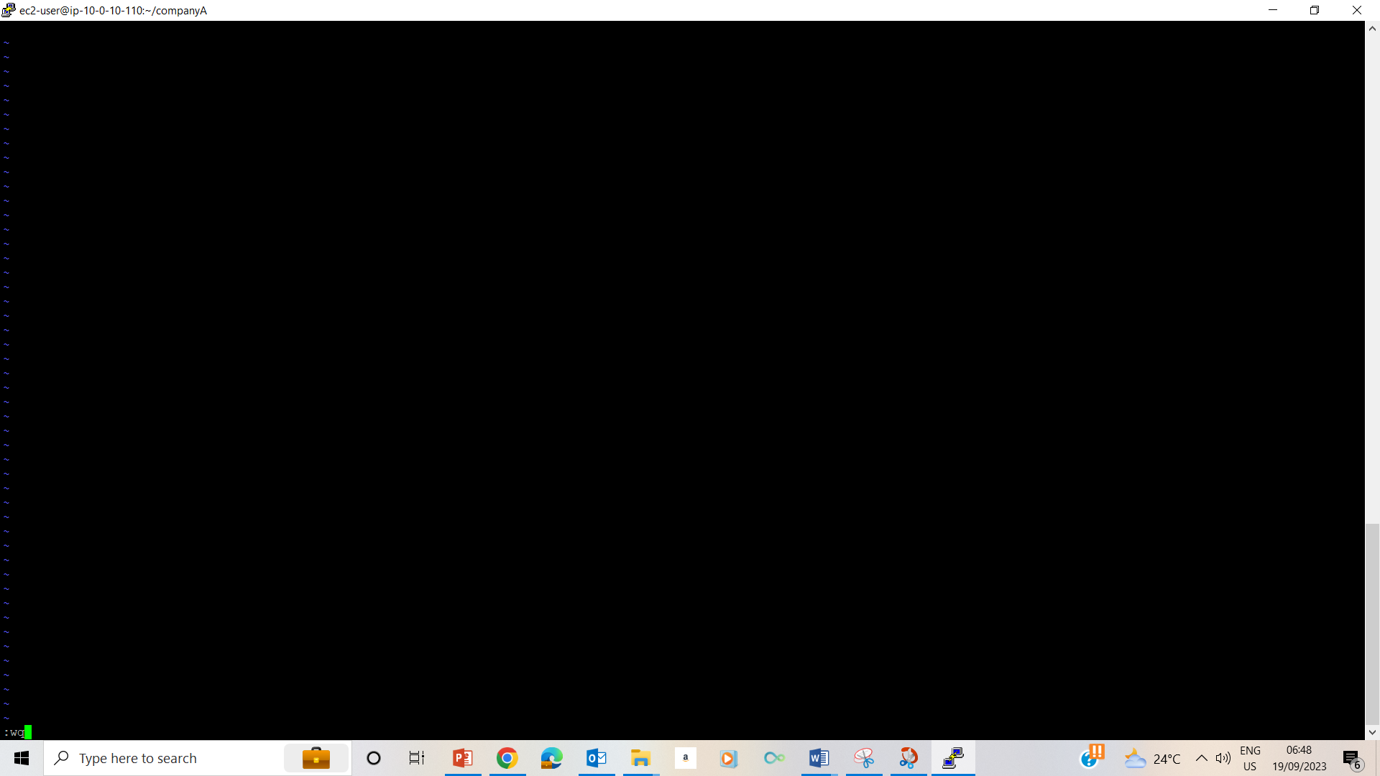

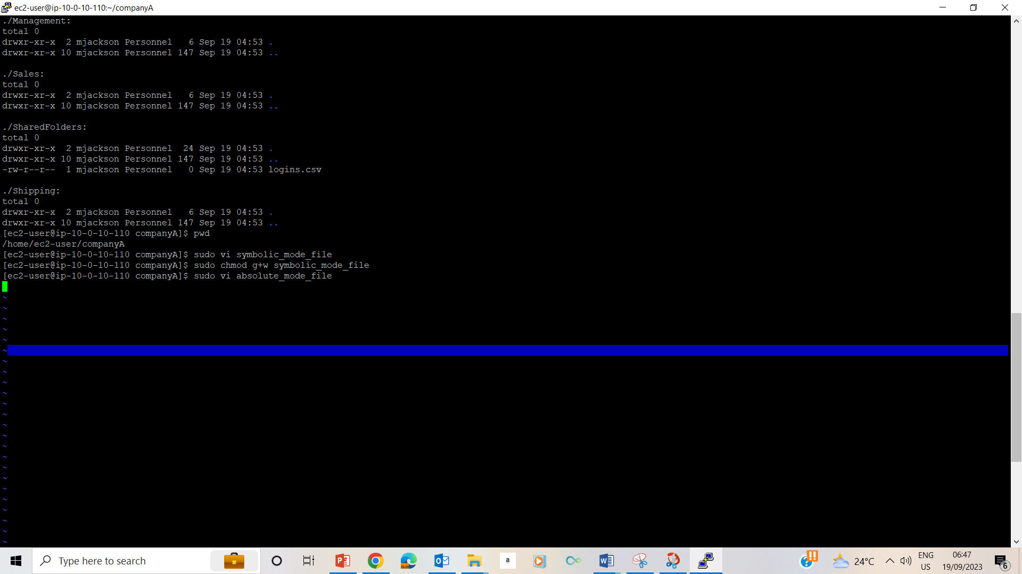

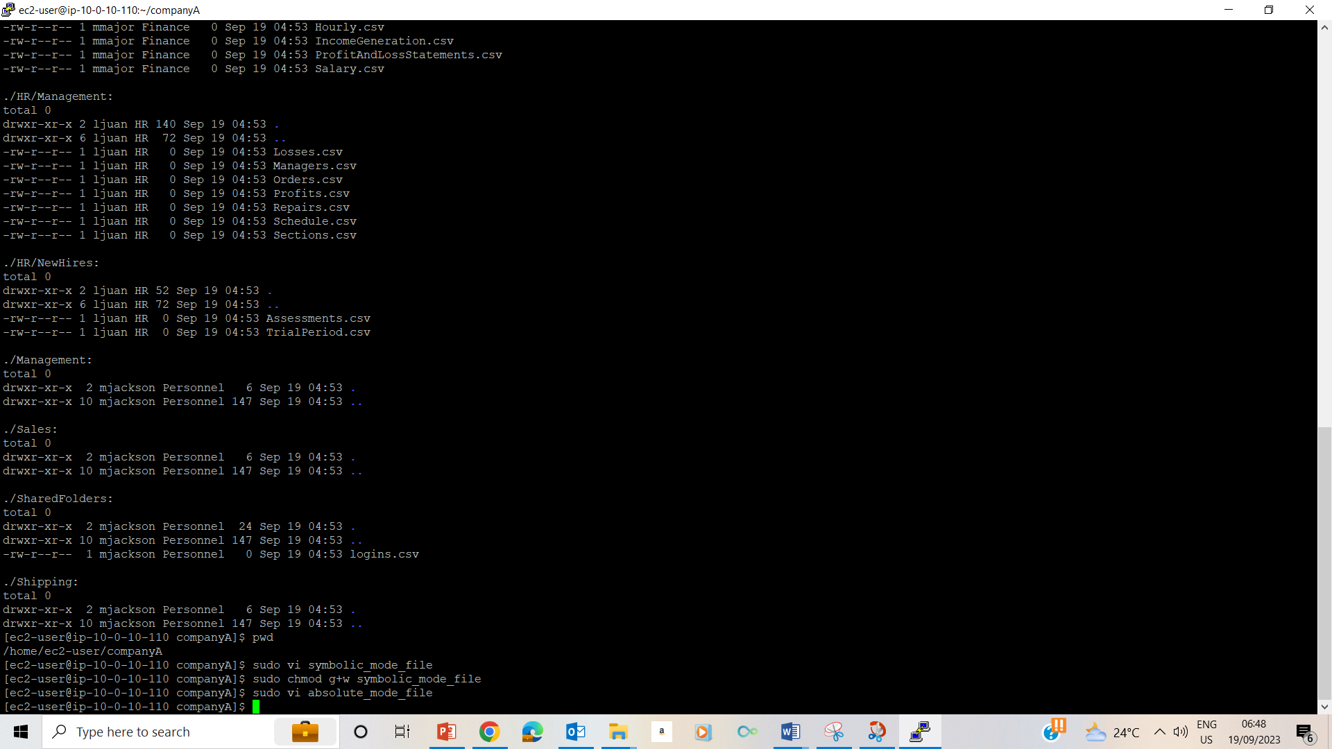

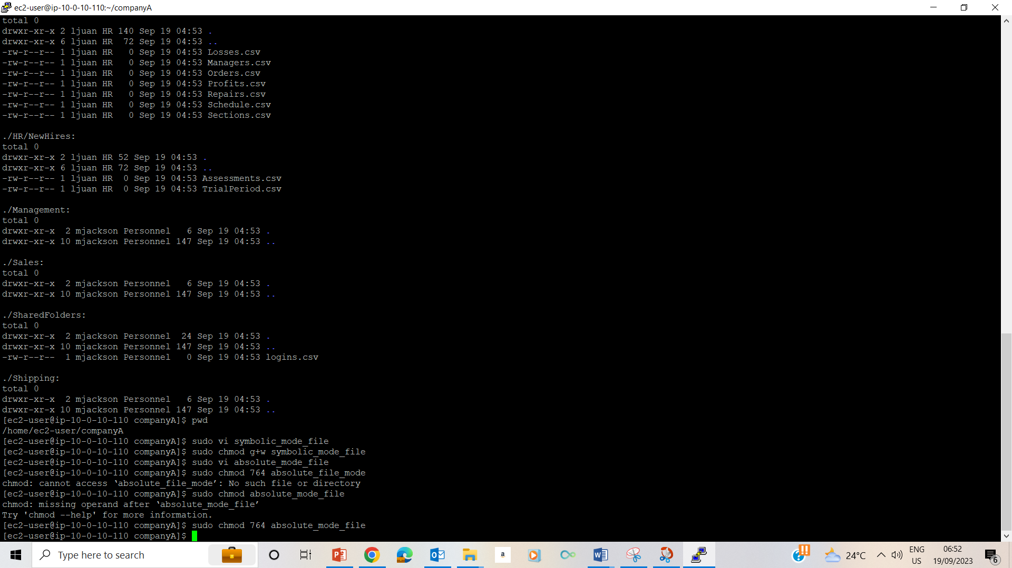

37&38- used vim to create absolute_mode_file and used absolute mode to change the file permissions

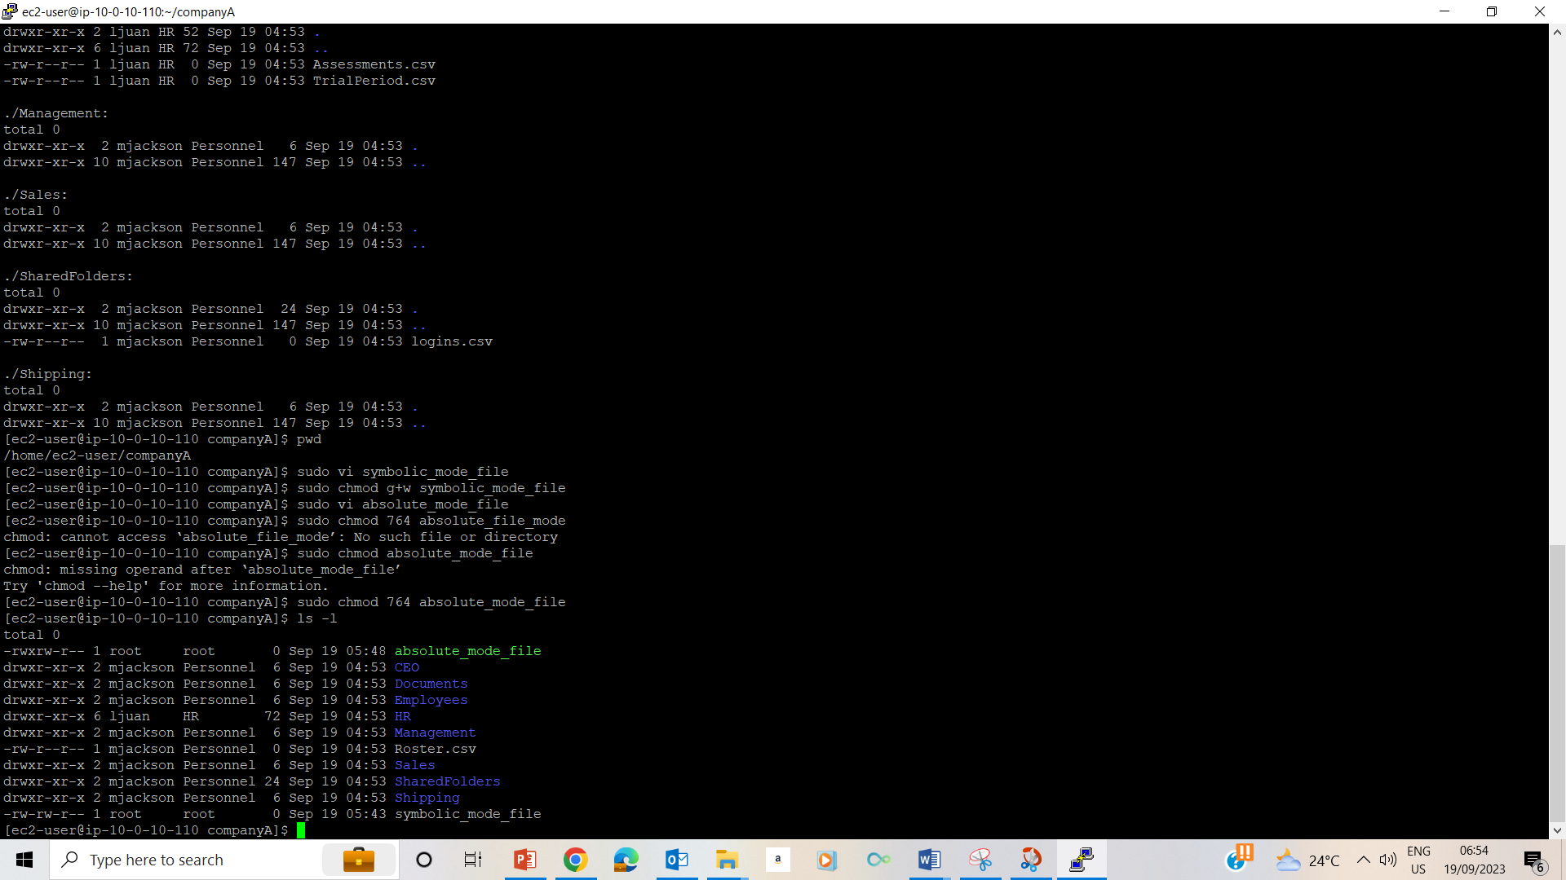

39 Used ls –l command to see the two files

## Task 4: Assign permissions

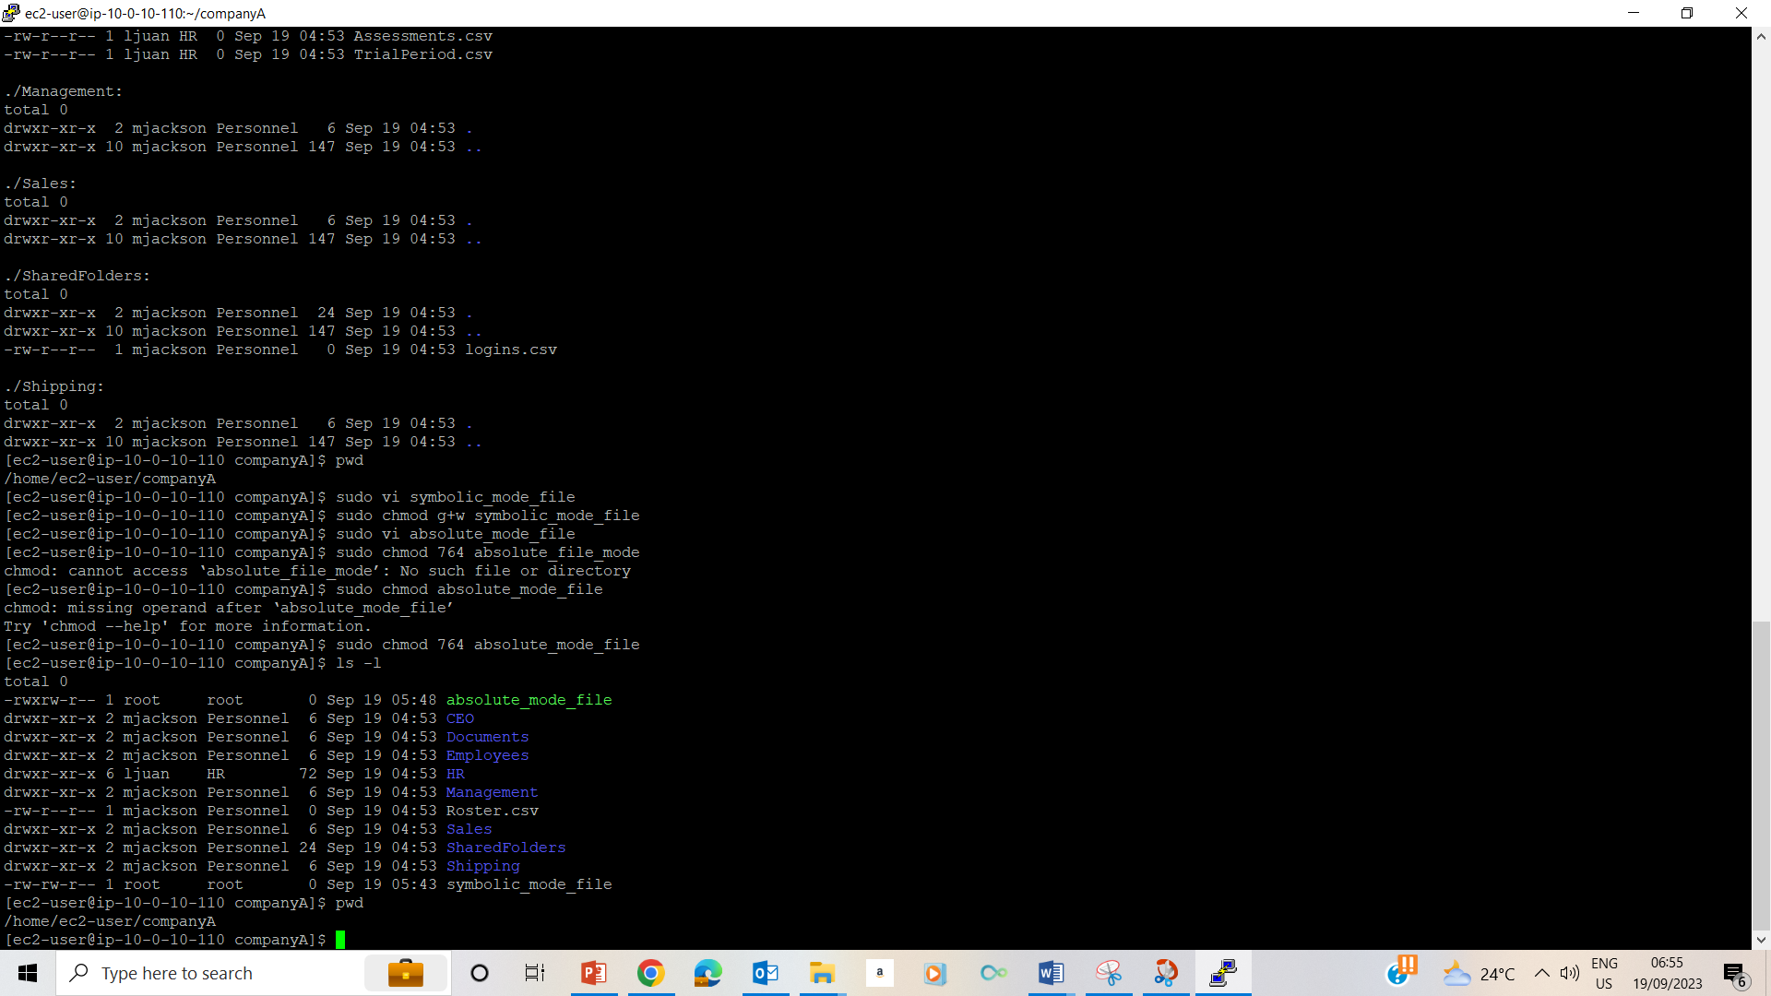

40. Used pwd to validate that I am in /home/ec2-user/companyA

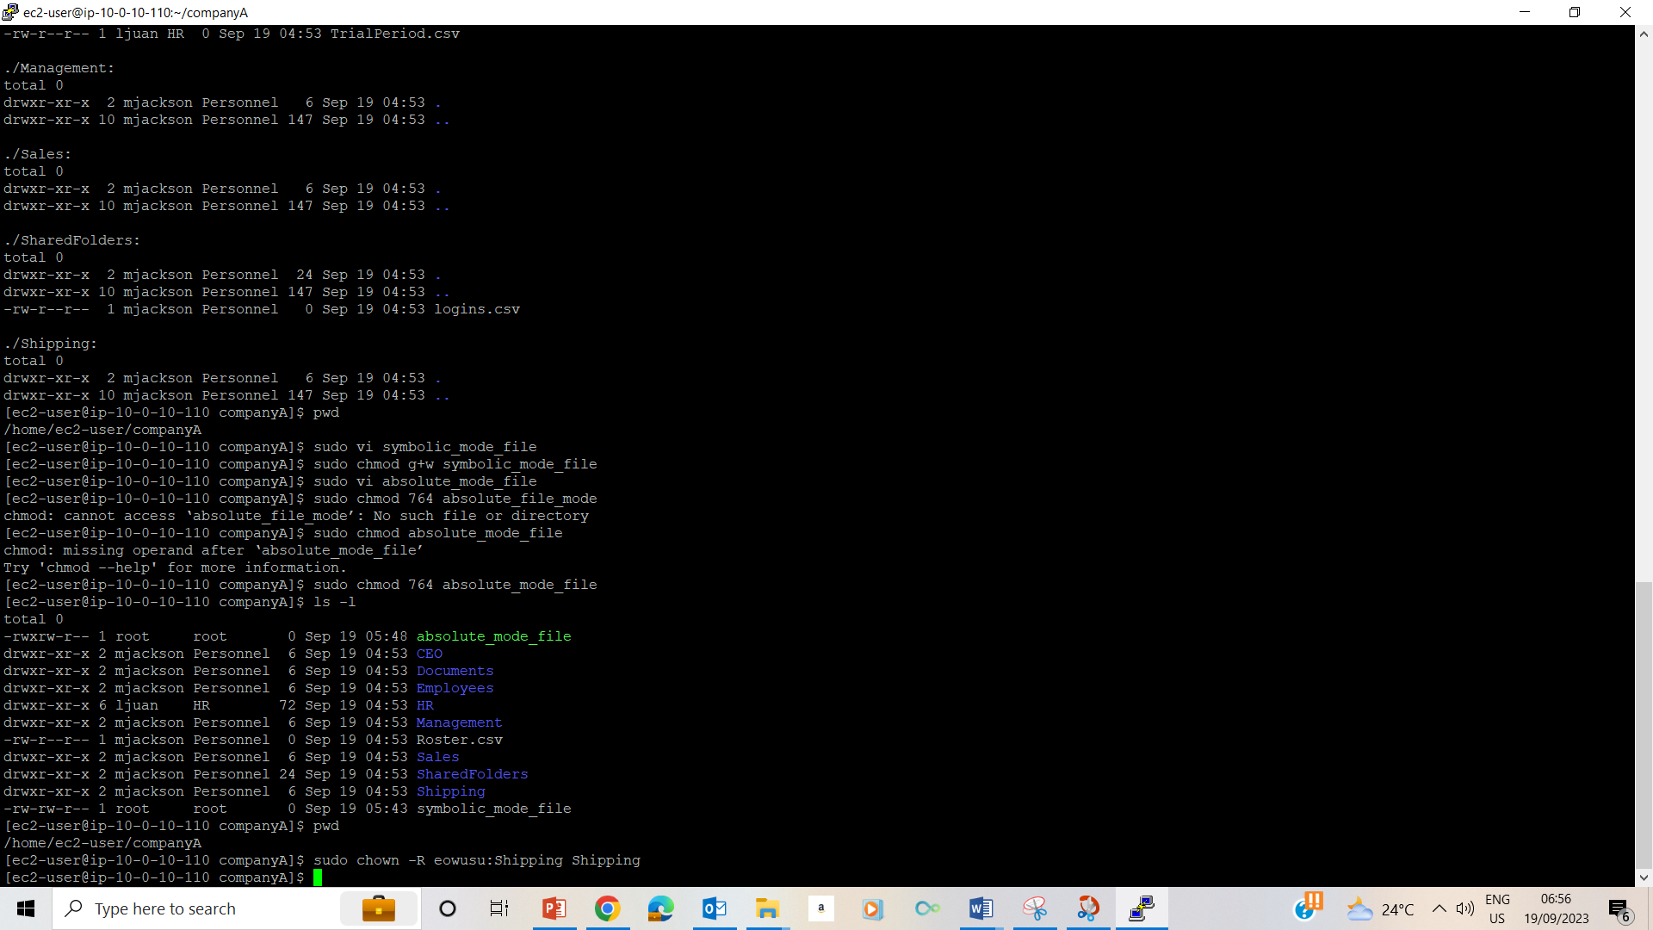

41. used sudo chown –R eowusu:Shipping Shipping to change ownership of the Shipping folder to eowusu.

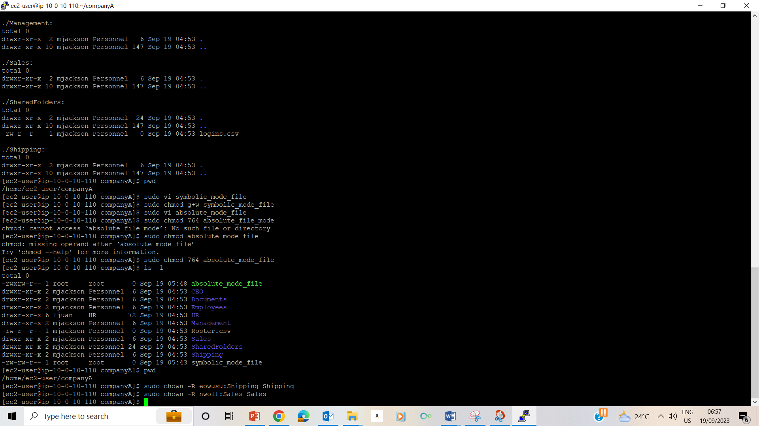

42. used sudo chown –R nwolf:Sales Sales to change ownership of the Sales folder to nwolf.

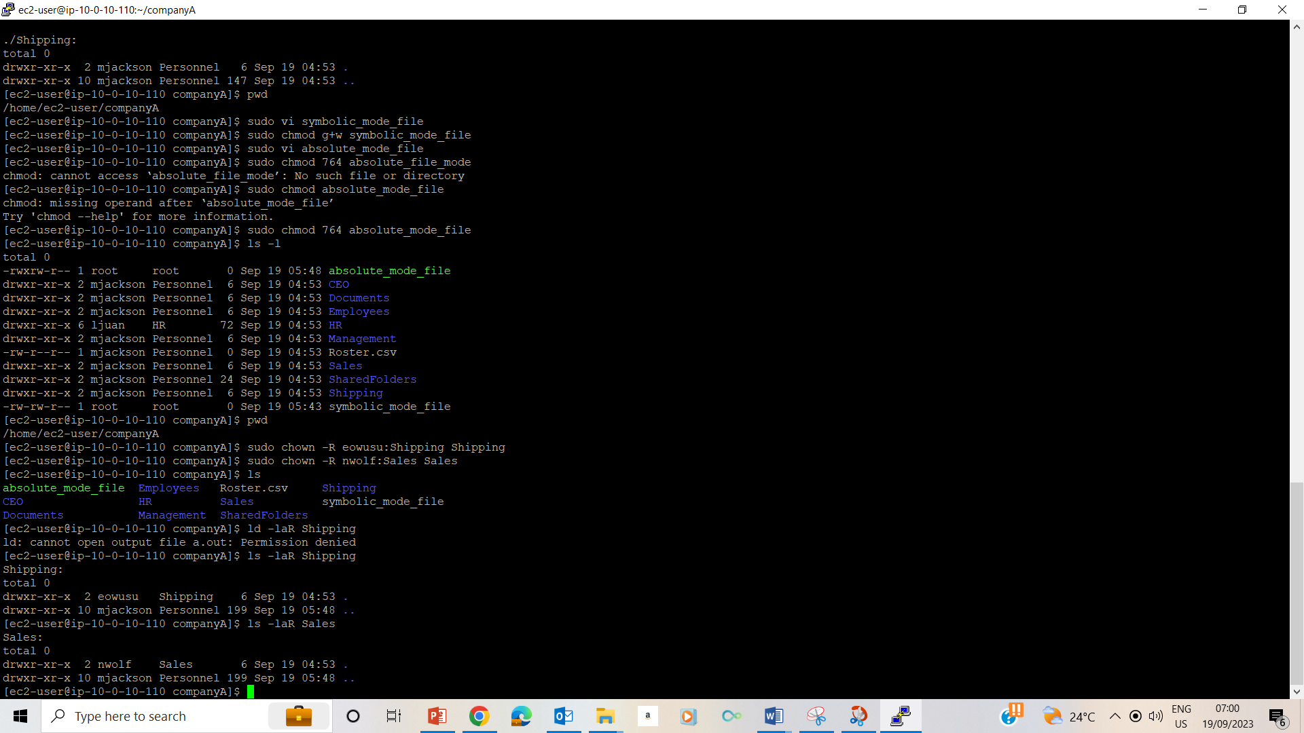

43. used ls –laR Shipping and ls –laR Sales to valide changes made to the Shipping and Sales folders respectively.

## Lab Complete

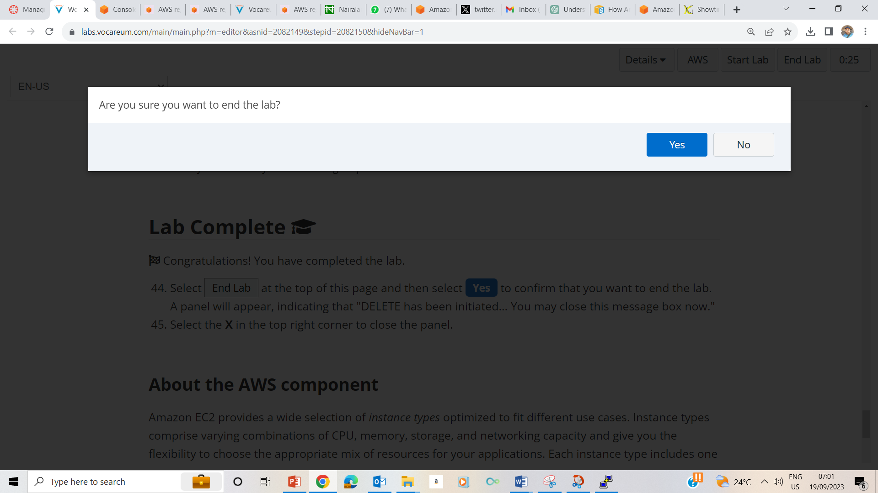

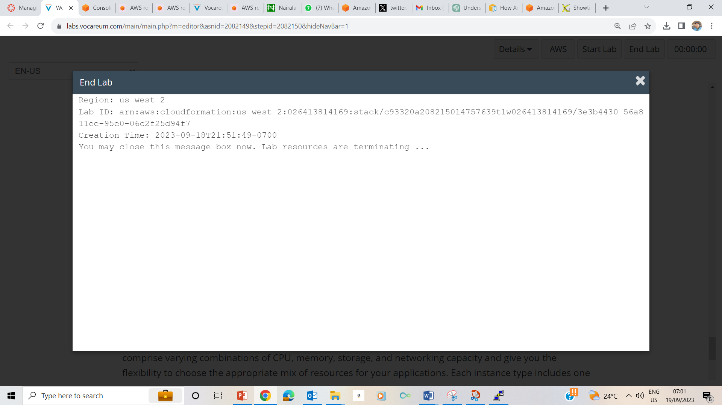

44. Selected End Lab at the top of the instruction page and selected yes.

45. clicked X in the top right corner to close the panel.